www.skyeloneragan.com
www.qpoetics.com
vimeo

Skye Loneragan is an award-winning writer/performer
and theatre director whose socially-engaged practice spans theatre, poetry and live art.
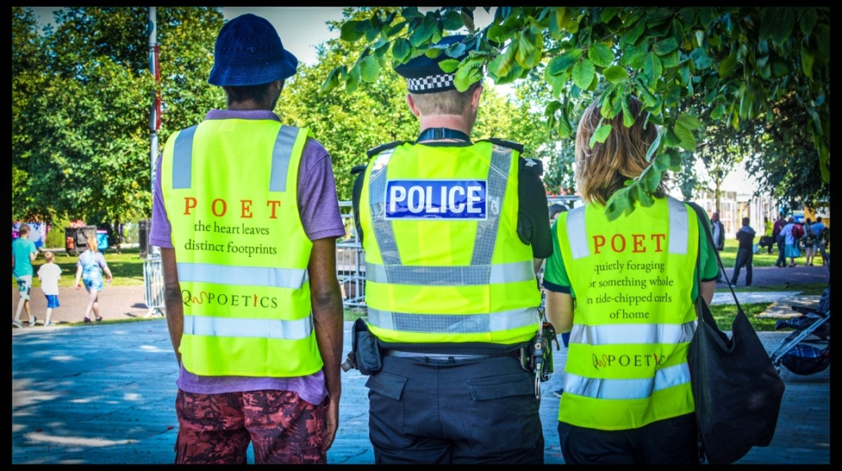
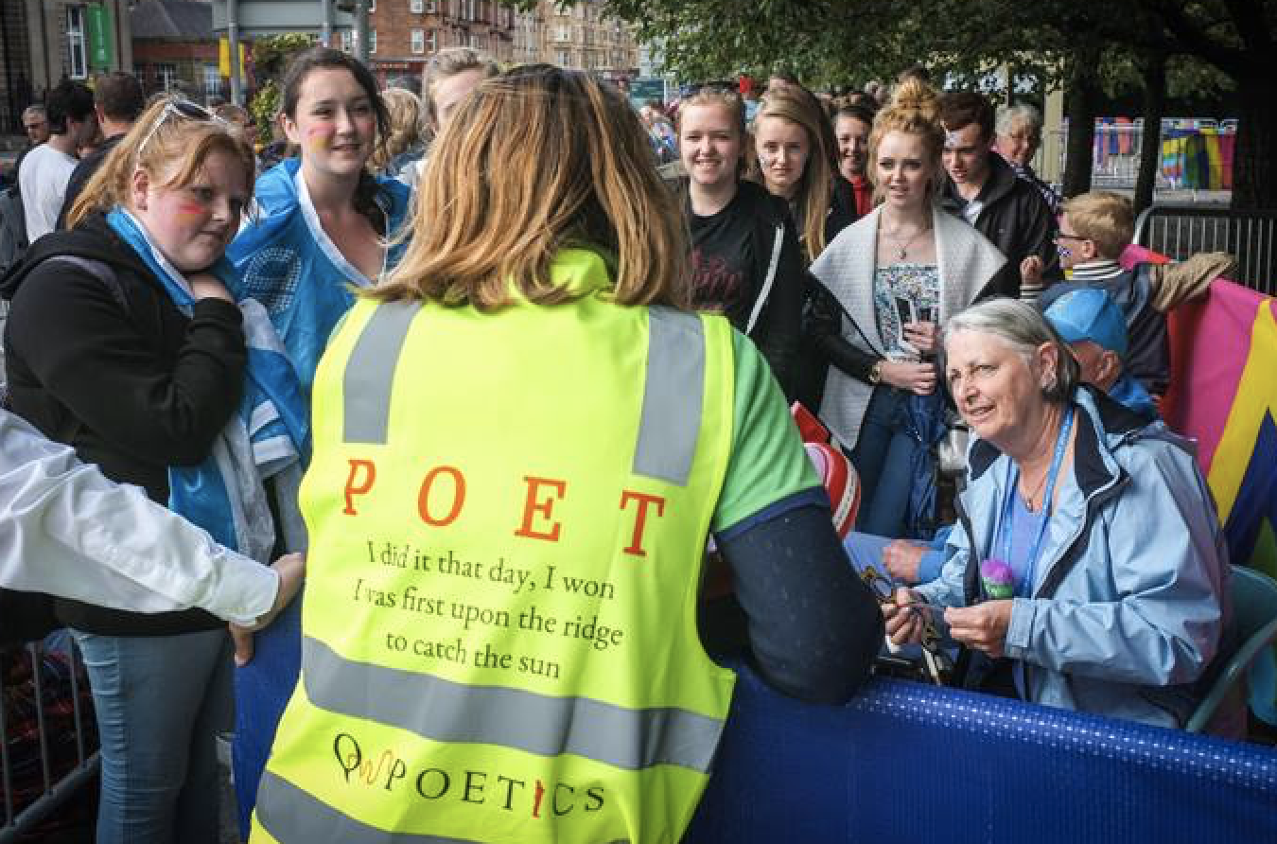
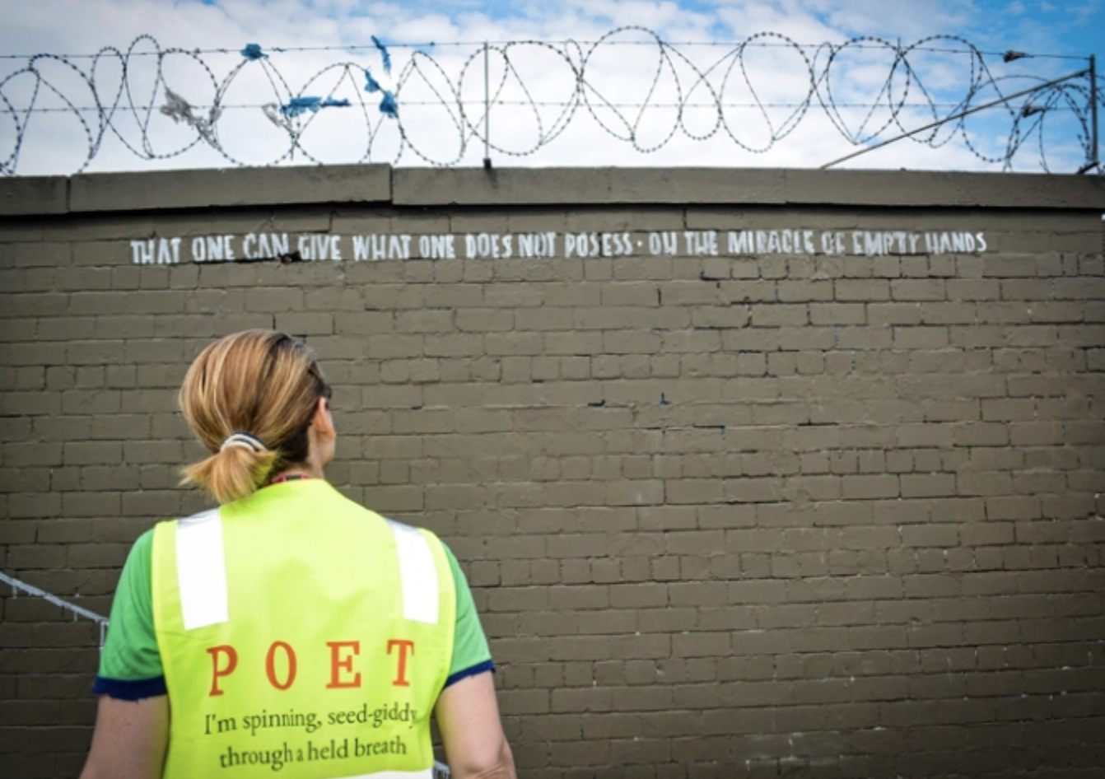

Q-Poetics / poet & poetry in places and spaces of waiting Photos: Stewart Ennis

Skye is working with the Scottish Book Trust’s as a writer-in-residence and working on a new play, The Turmeric Trail, for Imaginate, as an ‘Accelerator’ artist - The Traverse Theatre, Edinburgh. She is recent Artist-in-Residence with Glasgow Life, Ward 18 & commissioned playwright with Visible Fictions Theatre Company, and The Tron Theatre Glasgow. She is Lead Artist and creator of the public art engagement strategy, 'Q-POETICS', (poetry in places and spaces of waiting - queues), which premiered at the Sydney Writers Festival 2013, opened the Kelpies, and was part of Cultural Programme for Commonwealth Games, Festival 2014. Q-poetics worked with Wigtown Book Festival to connect residents of Dumfries & Galloway through the bus tour for Spring Fling 2016. The project emerged from the public art engagement strategy, Making a Map of My Mistakes – and Skye’s practice, working in places & spaces of waiting - and with the New Victoria Hospital Glasgow.

Skye’s first solo work, Cracked, (directed by Zinnie Harris) won an Edinburgh Fringe First and was adapted for radio, and her most recent, Though This Be Madness performed as part of the Scottish Mental Health & Arts Festival, now touring through Creative Scotland’s Touring Fund. Though This Be Madness is a piece which examines the stigma attached to mental health, particularly in relationship to women, through the sleep-deprived frame of new motherhood. Key collaborators on this piece were Playwright and photographer Stewart Ennis, and musician Mairi Campbell. Solo pieces include the verse piece drawn live called The Line We Draw for Flint & Pitch (following The Arches) & the poetry performance This Impossible Rim as Wigtown Book Festival’s 2016 writer-in-residence. Solo plays include Unsex Me Here & Plucked of Purpose- the Adventures of PB, which explores what the link is between our striving to fulfil ourselves, and landfill.
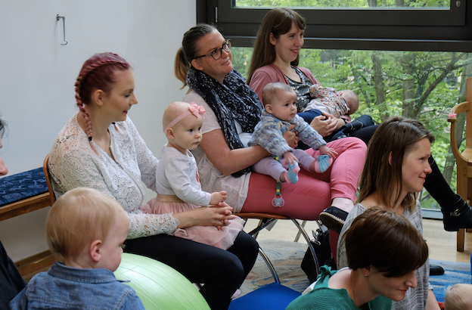
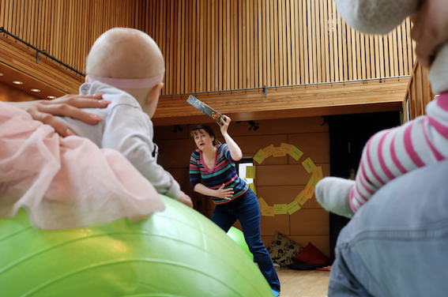
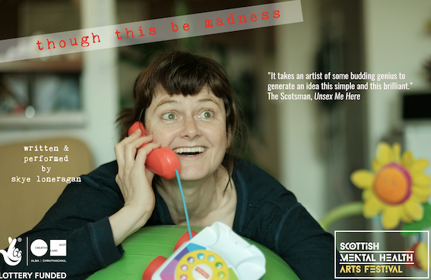

As Artistic Director for Toonspeak Young Peoples Theatre, Skye directed the Creative Scotland-funded, site-specific young-artist led works, ‘Lost & Found’ (Whisky Bond) and ‘Seven Signs’ (Merchant City, Glasgow) - co-writing with a cast of more than 30, 11-25yr olds and creating the spoken word project, Word of Mouth which focuses on young writer/performers. Collaborative work includes directing Ignite Theatre’s Under Pressure with children of refugees, and A Little Laugh I Lost Somewhere (Arches Theatre Young Directors Award).

Her residencies have included Playwright in Residence for Visible Fictions Theatre, out of which came the play for young people, Mish Gorecki Goes Missing (Tron Theatre), shortlisted for three UK awards. Skye is recipient of a New Writers Award for the children’s play, How It Became The Talking Stick, and FST bursary Unplugged for her research into writing for performance and installation art. Her research has taken her to outback Australia and a project endeavouring to explore inter-cultural approaches through collaboration with the Indigenous community of Alice Springs- touring to native title land and exploring the native relationship to land (out of which came a poetry collection).

Touring her performance poetry abroad to Asia-Pacific, she’s had been featured poet with the Sydney Morning Herald online app & is a Sydney Poetry Prize winner. Her poem Glasgow (We’ve All Been Here Before) was commissioned for theatre, Whatever Gets You Through the Night (directed by Cora Bissett). Poetry publications include contributions Buying Into The Property Market (GRIST Anthology UK, editor Simon Armitage) and The Grin Of Our Choices, (Abridged Magazine, UK).

Her projects engaging particular communities include:
- Ignite Theatre –Glasgow – “Under Pressure” deviser/director
- Scottish Mental Health Arts & Film Festival - writer/performer
- Whale Arts, Edinburgh (playwright, Climate Challenge Fund)
- Artlink Central (Stirling – Transitions Primary to Secondary Schools project)
- Baltic St Adventure Playground (Glasgow)- 3-7yrs - Sound and spoken word /feral play
- Q-Poetics– engaging with places/spaces of waiting. Installing the poet & poetry in queues.
- Glasgow International: public engagement program, Youth Intensive
- Writer-in-Residence, City of Sydney, Café poet - The Rocks Pop-Up Spaces & Scottish Book Trust.
- Performance in Education– tour of self-devised solo shows & creative writing workshops
- The Scottish Book Trust & Word Travels, Spoken Word – w/shops.
- Arts in the City – GlasgowLife, working with young people in care between foster homes
- Outside Art- a residency with The Tramway & GlasgowLife
- Making a Map of My Mistakes- a residency in The New Victoria Hospital, Glasgow
- Hidden Spaces – collaboration knitting communities together.
- Creative Identities – with young carers, a collaborative project with St Mungos Museum
- Word Travels (Australia) performance poetry to schools in regional areas of Australia
- Playwright in Residence with Visible Fictions Theatre Co, Greenock Academy

Collaborations include the on-going exploration, Skye & Skye on Skye with dancer Skye Reynolds which questions what really is in a name. She continues to work as a resident artist in many different community contexts, within HMPS and various community centres. Her most recent research project placed her within Glasgow Caledonian University’s Public Engagement as a Researcher working with Roma women in Govanhill, partnering with Soul Food Sisters, through the EU Social Innovation Fund. She is currently exploring how we re-imagine our relationship to environmental degradation that is within us as well as without us with GCU School of Health & Life Sciences.

She currently works as a storyteller and performance poet for the Scottish Book Trust (Live Literature), internationally for Word Travels (spoken word, Australia) and Sense Kaledescopes (Bangalore) working with autistic children and as a recent director/tutor with the Scottish Youth Theatre.

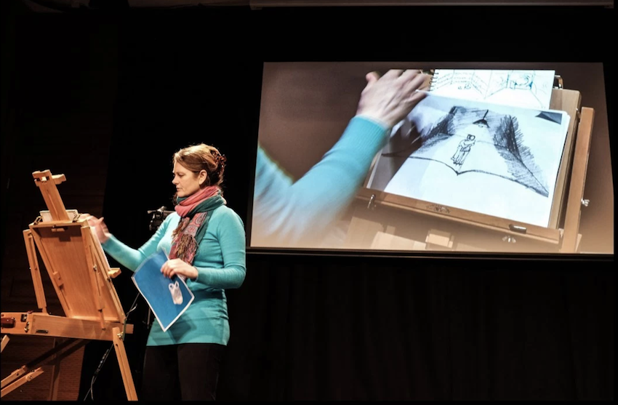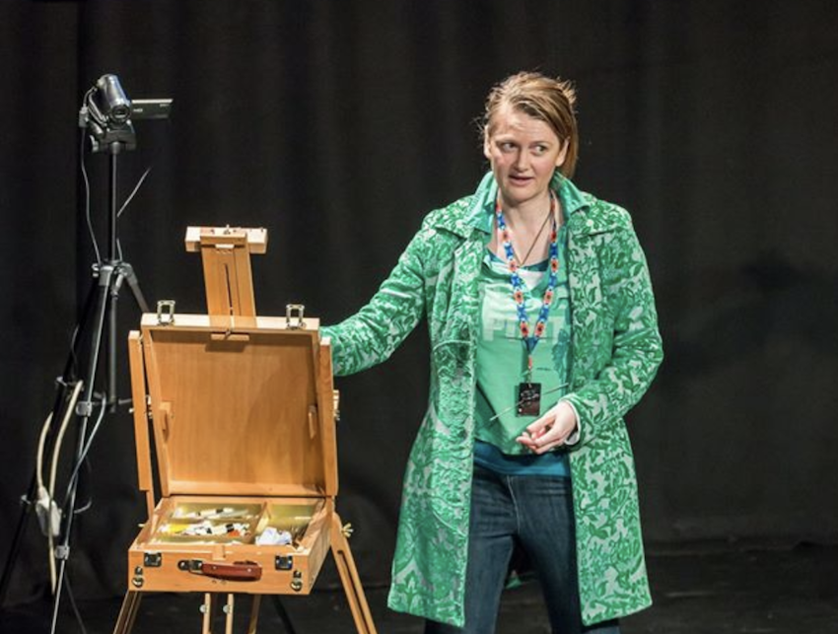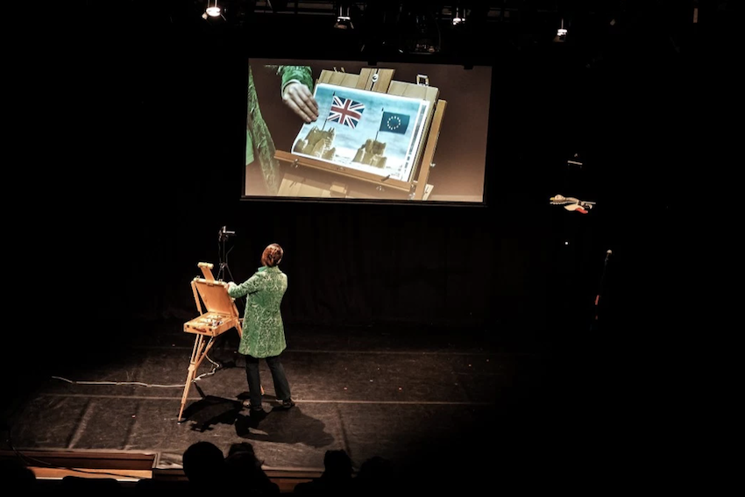

The Line We Draw – solo performance Photos: Stewart Ennis

Critical Acclaim:

“Loneragan is such a gifted and engaging performer, both in words and movement, that the quiet integrity of her unadorned staging finally comes to seem like a gift; in a show that talks of madness, but also of how women’s lives, honestly described, always tend to defy the norms of our culture – including our ideas of sanity and exactly what it might look like.”
(Joyce McMillan, Scotsman, THOUGH THIS BE MADNESS 2018)

“A tiny, but almost perfect show….a haunting reminder of some of the big questions asked”
(Joyce McMillan, The Scotsman, CRACKED.)

“In a kind of acute free verse rendering that might’ve come from Shakespeare were he alive today and on uppers, Loneragan poses provocative questions with the most vigorous, surefooted delivery imaginable” ( Crickey, THE LINE WE DRAW)

“It takes an artist of some budding genius to generate an idea this simple and this brilliant”
(Joyce McMillan, The Scotsman UNSEX ME HERE)

“…a colourful litany of love lost and found and the comforts of madness in the face off an all too serious big, bad world of adulthood. ….take your time to be small is Loneragan’s overriding instruction…” (The Herald, Neil Cooper, THE LINE WE DRAW).

“…no one notices that Mish Gorecki has actually gone missing. No laughing matter, and yet writer Skye Loneragan contrives, without being facile, to flip the potentially grim scenario of Mish’s messy existence into something genuinely life-affirming and hilarious to boot”
(Mary Brennan, The Herald, MISH GORECKI GOES MISSING

